DYNAMICALLY CHANGING SIGNAL LIGHT TIME ALLOTMENT IN STREET JUNCTIONS BASED ON TRAFFIC DENSITY

ABSTRACT
The project is designed to develop a density based dynamic traffic signal system. The signal timing changes automatically on sensing the traffic density at the junction. Traffic congestion is a severe problem in many major cities across the world and it has become a nightmare for the commuters in these cities.
Conventional traffic light system is based on fixed time concept allotted to each side of the junction which cannot be varied as per varying traffic density. Junction timings allotted are fixed. Sometimes higher traffic density at one side of the junction demands longer green time as compared to standard allotted time. The proposed system using a microcontroller of PIC16F8 series duly interfaced with sensors, changes the junction timing automatically to accommodate movement of vehicles smoothly avoiding unnecessary waiting time at the junction. The sensors used in this project are IR and photodiodes are in line of sight configuration across the loads to detect the density at the traffic signal. The density of the vehicles is measured in three zones i.e., low, medium, high based on which timings are allotted accordingly.
Further the project can be enhanced by synchronizing all the traffic junctions in the city by establishing a network among them. The network can be wired or wireless. This synchronization will greatly help in reducing traffic congestion.

BLOCKDIAGRAM

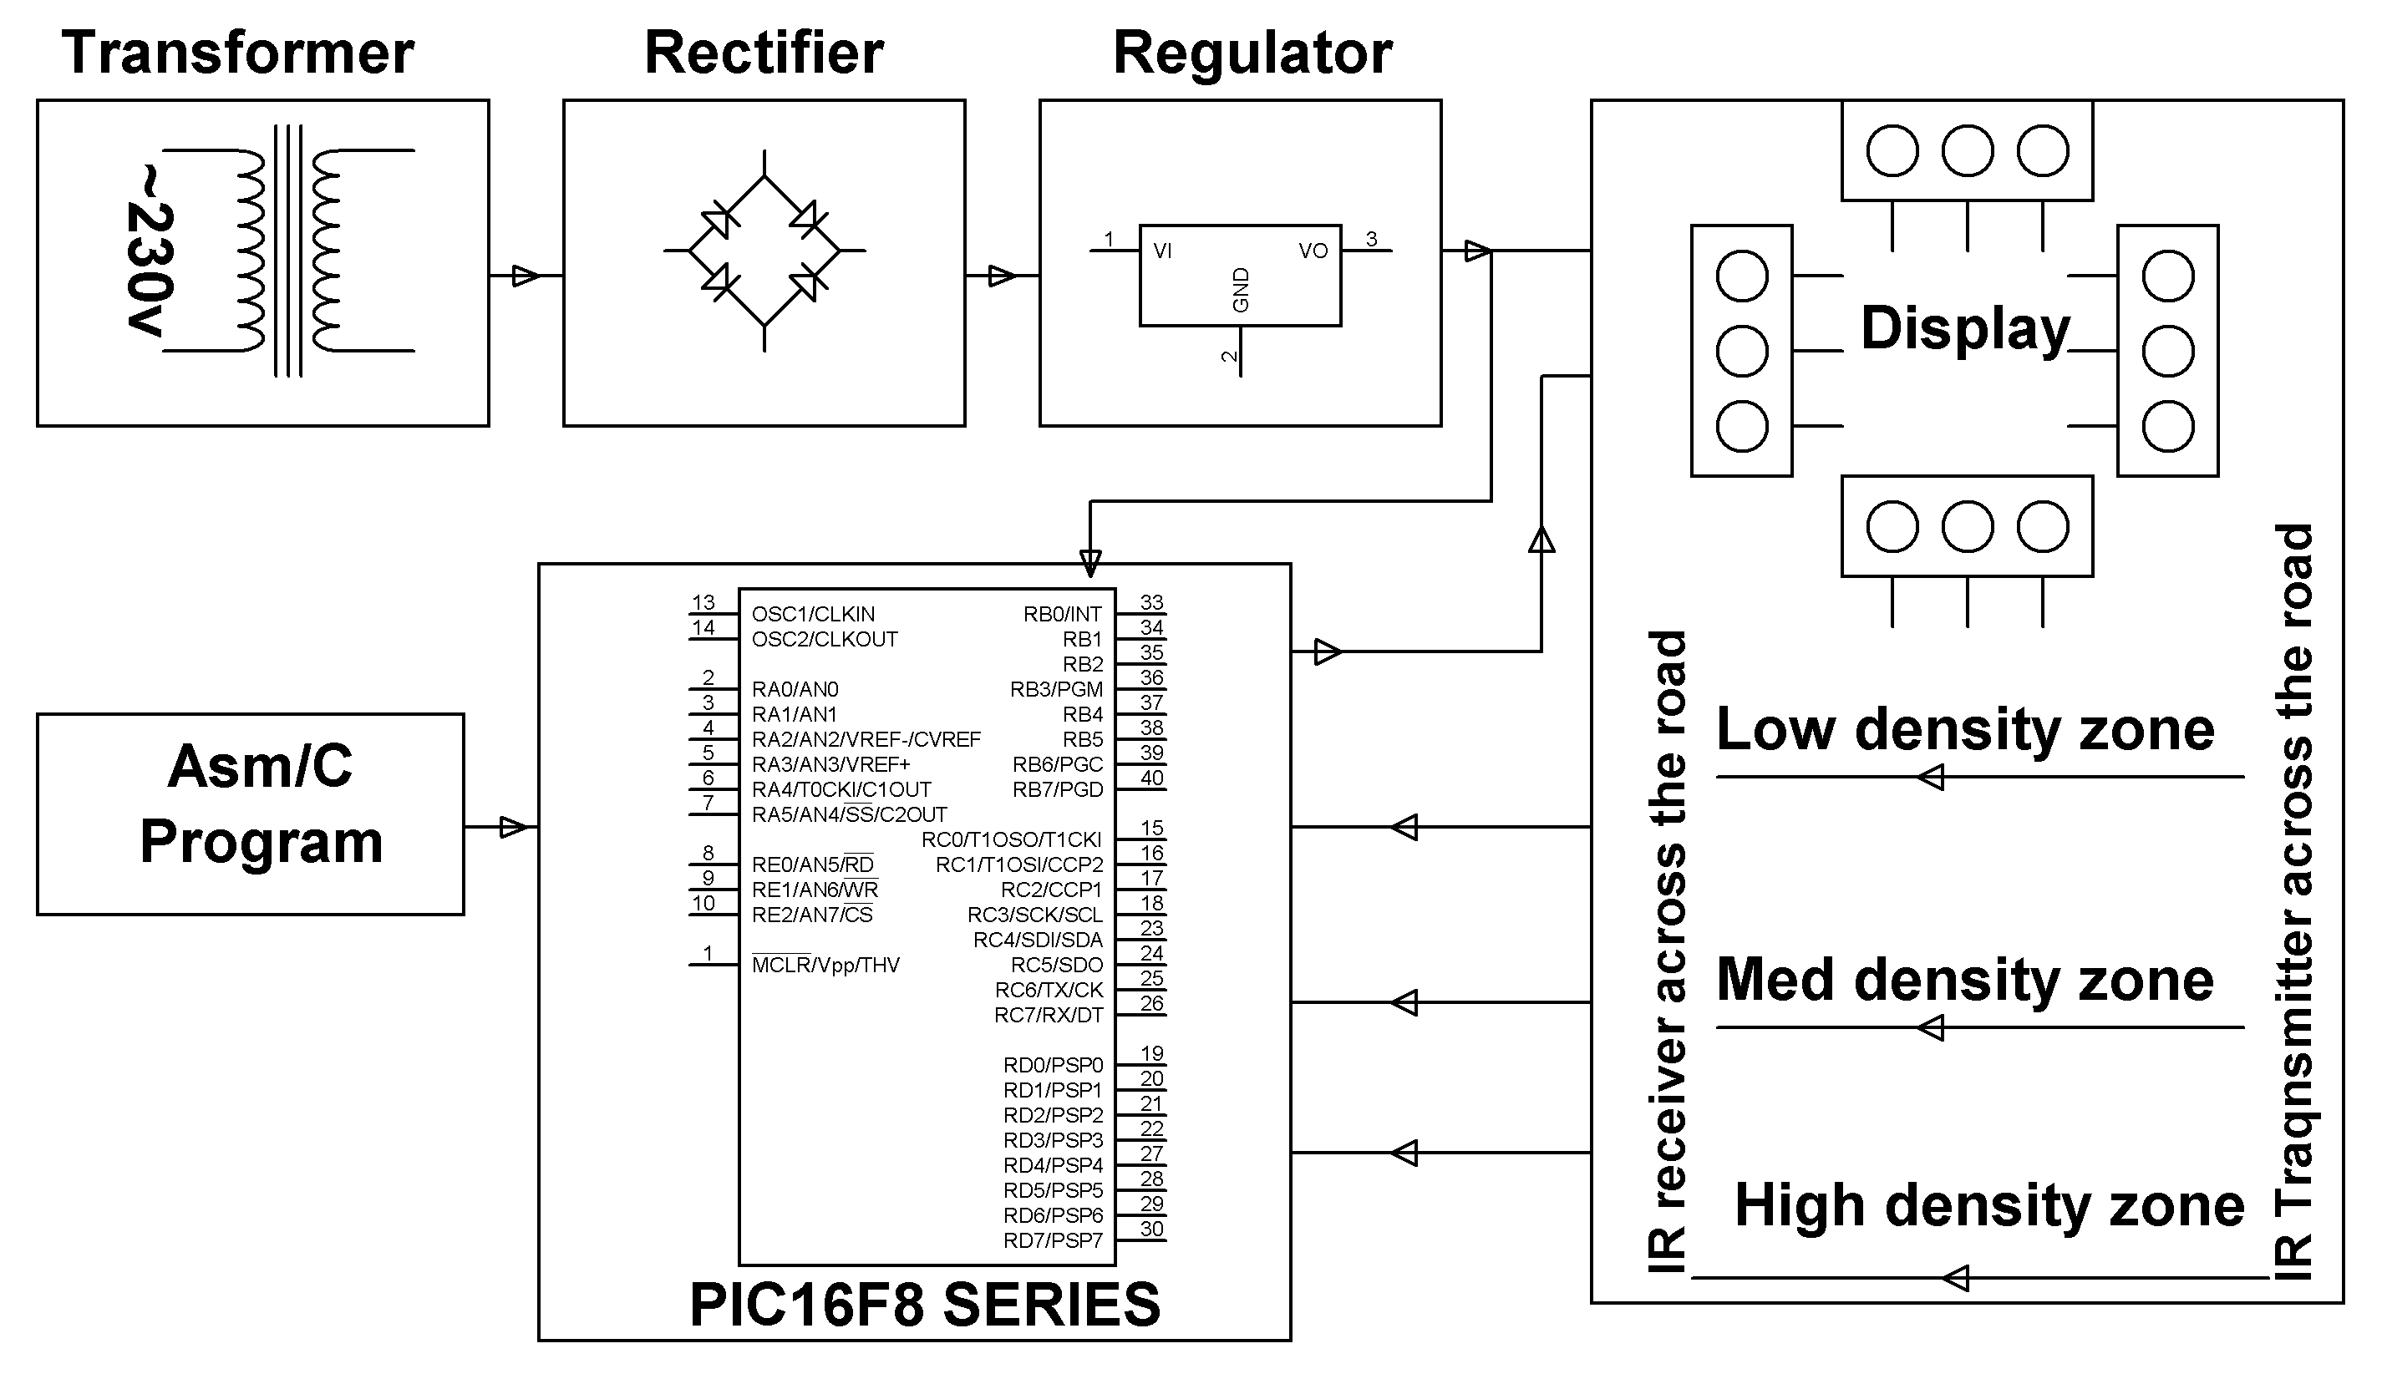

HARDWARE REQUIREMENTS:
PIC16F8 series Microcontroller, LEDs, Voltage Regulator, Resistors, Capacitors, Crystal, Diodes, Transformer, IR & Photodiodes.

SOFTWARE REQUIREMENTS:
MPLAB & CCS C compiler

Language: Embedded C or Assembly.

